FACULTY NEEDS ASSESSMENT APPLICATION

Name of Person Submitting Request: |  | Celia Huston
Program or Service Area: |  | Library & Library Lab
Division: |  | Library and Learning Resources Division
When was the last Program Efficacy document completed? |  | Fall 2009
What rating was given? |  | Continuation
# of FT faculty 3 | # of Adjuncts 1 | Faculty Load 6.5 (per Title 5:58724)
Position Requested |  | Librarian

- Provide a rationale for your request.
The Library requests another faculty Librarian position to ensure that student needs and class instructional needs are met in a timely manner. There has been a significant increase in the number of students who are entering the college without sufficient training in basic information literacy skills, requiring the librarians to spend more time teaching students to navigate research resources and bringing them up to speed, technology-wise, so that they can use the online catalog, databases, and computer lab.

Historically, one faculty librarian was scheduled to work with students at the reference desk. In Spring 2008, statistics showed that two or more faculty librarians were required at the reference desk for 23.7% of available hours. Since Fall 2009 two librarians are now scheduled to work the reference desk 66% of the daytime hours. The increased demand for direct student contact limits the amount of time librarians are able to spend supporting and developing the infrastructure of library services including, database and online catalog maintenance, development of information literacy materials and basic skill collections and services.

- Indicate how the content of the EMP One-Sheet and latest Program Efficacy Report support this request. How is the request tied to program planning? (reference the page number(s) where the information can be found on the EMP and Program Efficacy).
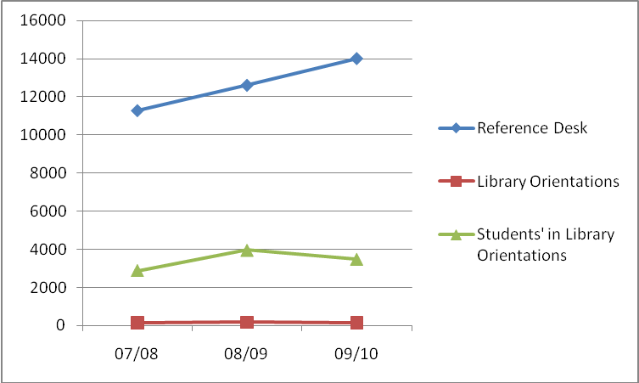The Library and Computer Lab have not been included in the current Educational Master Plan, but will be included in the next plan update. The Library and Computer Lab tracks a variety of statistical data. Data that reflects library faculty’s direct interactions with students includes working with students one-on-one at the reference desk and library orientations.
From 07/08 to 09/10 there has been a 24% increase in the number of reference student contacts with library faculty at the reference desk. From 07/08 to 08/09 Library Orientations rose 19% then dipped back down. This is attributed to the reduction in library services hours and library closure on Saturdays. Summer library orientations have declined as the number of summer sessions have been reduced and summer session has a greater emphasis on online classes. When the Library last completed Program Efficacy in 2008, faculty librarians planned (p.16) to market library orientations outside the mainstream Humanities and Social Science classes that typically schedule orientation. Since Fall 2008, faculty librarians have started conducting specialized orientations for Math, Health, Child Development and Spanish. The addition of these disciplines has held the number of library orientation at 07/08 numbers despite the reduction of service hours and days. Additionally, faculty librarians now offer library workshops 6 – 8 times a semester that are open to the general student populations (i.e. students do not have to come to the workshop with a class).

- Provide updated or additional information you wish the committee to consider
(for example: regulatory information, compliance, updated efficiency and/or student success data or planning etc).
- SBVC Library is below Title 5 minimums for library faculty. Title 5 58724: Tables for minimum standards for libraries and media centers. SBVC’s target goal for FTE’s in 2010/2011 is 10,001 this would = 6.5 Library Faculty according to Title 5.
- SBVC Library has fewer faculty than nearby colleges.
College | Collection | Faculty | Staff
Riverside CC | 290,826 | 8 | 21
Victor Valley College | 150,485 | 3.71 | 10
Chaffey College | 181,550 | 4.75 | 12
(Source: California Library Association Statistical Handbook 2009)
- The Library and Learning Resources Division has been approved and ranked for a faculty librarian during the past two needs assessment cycles and the position has not been filled.

- Evaluation of related costs (including any ongoing maintenance or updates) and identification of any alternative or ongoing funding sources. (for example: Department Budget, VTEA or Perkins).
Entry Level Salary based on 2008 salary schedule is 49,033.61, plus benefits. Funding is ongoing
- What are the consequences of not filling this position?
Library faculty will be unable to continue supporting and developing the infrastructure of library services including, database and online catalog maintenance, development of information literacy materials and basic skill collections and services. Library faculty will have to reduce the number of library orientations and workshops offered. In addition, librarians will be forced to turn away the hundreds of non-students who come to them for help in applying to the college, completing their registrations, or filling out FAFSA forms due to being forced to choose between currently-enrolled students needing their help with assignments—the major role of the reference librarian—and helping those who require assistance with registration or financial aid functions not directly tied to classroom success. Finally, if the position is not filled, students will soon be met with an empty reference desk and a lengthy wait for reference librarian services.

